**installing and operating instructions for touchscreen**

**1, Important considerations of touch screen**

**2, Transportation and after-sales warranty of touchscreen**

**3, Installing guide of** **touchscreen**

**4, Detail description of touch screen interface**

**5, Data line PIN definition diagram of touch screen**

**6, Upgrade procedure guide of touch screen**

**7, Touchscreen test guide**

**8, Direction change guide of touchscreen**

**1, Important considerations of touch screen**

1.1 When the touch screens are transported to the buyer's warehouse, please confirm whether the product model, control card model and quantity are correct at the first time.

1.2 Please place the touch screens in a stable and safety place,preventing the product from being hit.

1.3 Generally, cover lens face is up. Usually, the sensor should be tested on a soft insulating item, and there should be no conductive items below it, otherwise serious interference will occur,leading to problems ,such as jump point and broken wire.

1.4 When the touch screen data cable is changed, please connect strictly as manufacturer’s PIN definition interface, otherwise the power will burn the control card IC.。

1.5 The touch screen can be installed only after the electrical test of incoming material has passed.After installing, it’s need to retest electrical and , it shows the hardware of touch screen is nomal(Test is passed), then can be shipped.

1.6 Each machine needs to be tested before mass production, avoiding a wide range of functional abnormalities after mass production

**2, Transportation and after-sales warranty of touchscreen**

2.1 Transportation: In order to ensure that you receive the perfect goods, please confirm that the product packaging is in good condition when receiving the goods. On the day of receipt, you need to open the package to confirm whether the touch screen, control card and wire in the packaging box are correct, and count the quantity.

2.2 After-sales warranty: the warranty time of the product is calculated from the purchase date, and the warranty period is one year. Please store the touchscreens as storage environment (storage environment: Temperature 20°±5° humidity 40%RH±10%RH) .Do not store products in humidity, high temperature place. Within warranty period, due to the quality of the product ,that causes abnormal work, our company will provide free maintenance services. In the following cases, free maintenance is not provided

2.2.1 Products or parts exceed the specified warranty period

2.2.2 Failure or damage caused by wrong and improper use or storage, such as improper carry,insertion and removal of external equipment, falling or external force stamping,etc

2.2.3 Due to the expiration of the warranty period or some equipment are not within the free warranty regulations , users can still get our company's maintenance services, but need to charge for accessories and maintenance cost.

**3, Installing guide of touchscreen**

3.1Before installation, pay attention to the function and appearance test of the

touch screen, and the test result should be pass before going online. For appearance test, please refer to the "Dongguan Yuefeng Appearance Inspection Standard". For function test, please refer to the attached "Dongguan Yuefeng Test Guide".

3.2 Avoid scratches or damage to the touch screen SENSOR and FPC during installation. If these accessories are damaged, the touch screen function will be poor and can’t be repaired.

3.3 When installing, we advise to separate the TP(less than 21.5") from module with 1.5-2mm hard foam to reduce the excess interference caused by the module on the touch screen, avoiding the phenomenon of skipping or breaking the cable. For 21.5 "to 32" TP,we advise to separate them from the module with 2 -3mm hard foam. When the TP is larger than 32 ", we advise to separate them from the module with 3 -5mm hard foam,as shown in the following figure

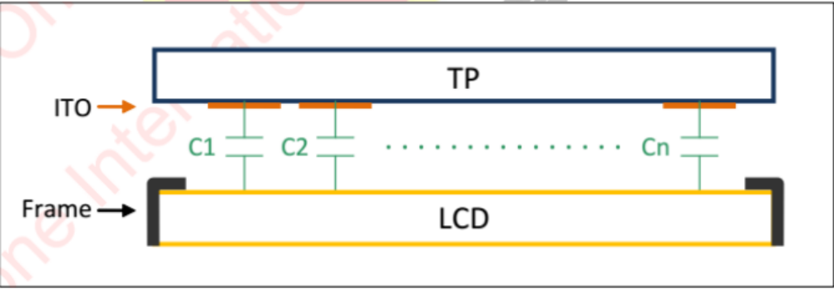

3.4 In order to ensure the stability of whole machine capacitor, when designing the whole machine structural, the touch control card, display module, and the metal structure of the whole machine must be well grounded,as shown in the following figure

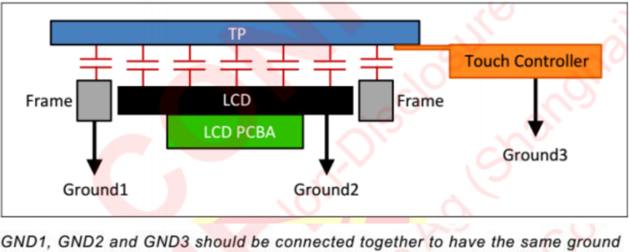

3.5 The touch control card is fixed with screws (as shown below), which can ensure the hardware shell, capacitive touch card, and display module are well grounded. If use the conductive cloth or grounding wire,after a long time,it may not be firm enough and the grounding effect is relatively poor.

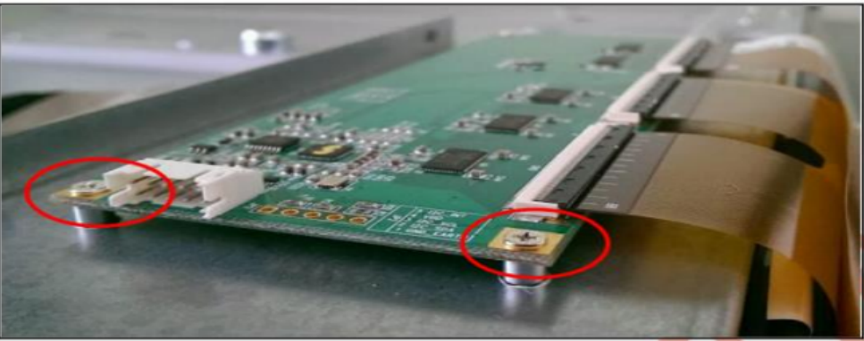

3.6 Whether the touch screen is attached to the hardware frame or embedded in the hardware, ensure that the inner edge of the hardware is prohibited from entering the operating area of the touch screen,which prevents the hardware from interfering the edge of the touch screen

3.7 Please fix the FPC flexible flat cable on the touch screen. If the cable is not fixed, it may cause parasitic capacitance interference, which will affect the touch performance (as shown below). In addition, it must avoid to full fold or fold the FPC over and over again (as shown below).

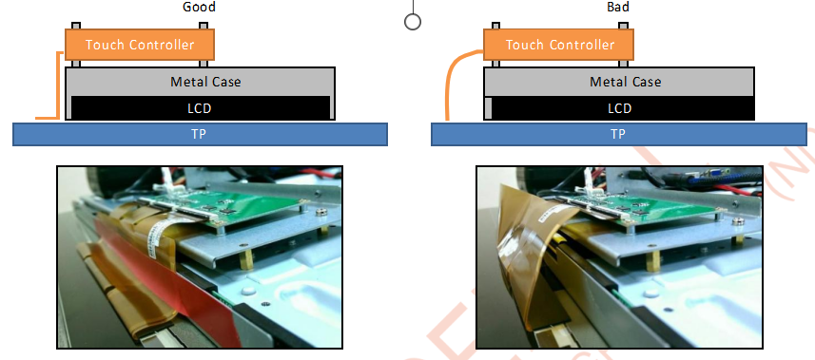

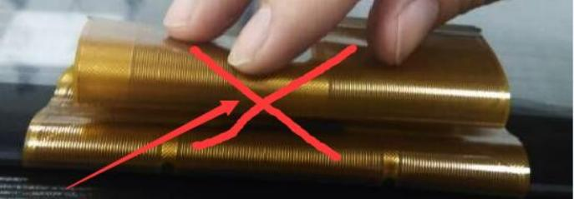 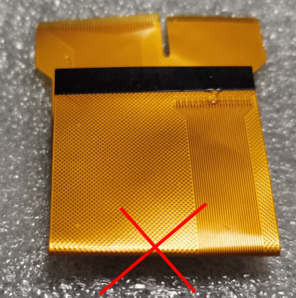

3.8 Do not put the touch control card and the flexible flat cable through above or below the high frequency signal and the host power supply. If you must do this,pls separate the high frequency signal from the touch pad and the cable with insulation tape, which is to prevent other components from interfering the touch screen.

3.9 Liquid water will affect the change signal of capacitance , and its effect to the capacitor screen is different in different humid environments

|  |  |
| --- | --- |
| circumstances | touch effect |
| Wet fingers | slight influence on sensitivity and linearity |
| water mist/dampness | Have some influence on sensitivity and linearity |
| water drop | When you draw line through the water drop, it will cause false alarms, broken lines or jitterce |
| The poured water | When you draw line through the poured water , it will cause obvious false alarms, broken lines or jitterce |
| puddle | When you draw line through the puddle , it will cause obvious false alarms, broken lines |

3.10 The more water there is, the higher conductivity will be, and the greater interference will be (as shown below).

Less water more water

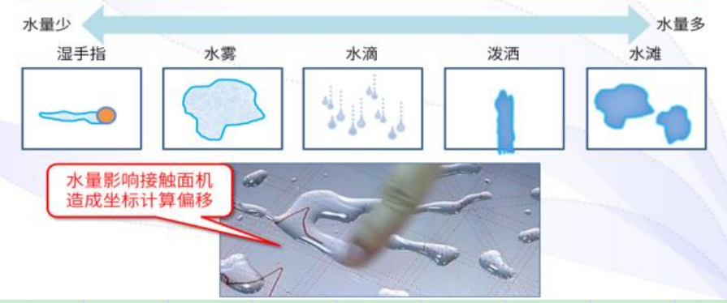

3.11 In order to reduce touch interference and make touch function stable, downtouch is changed to single-finger or two-finger touch, as shown below;

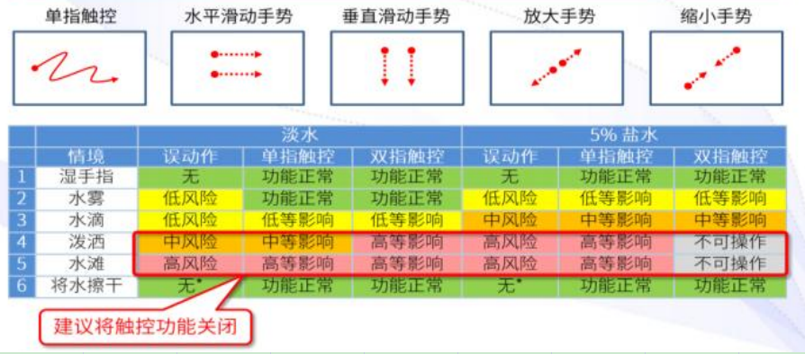

For waterproof design, we have the following suggestions:

3.11.1 The full plane design will have a better waterproof effect, which can avoid water accumulating on the surface of the touch screen, as shown below

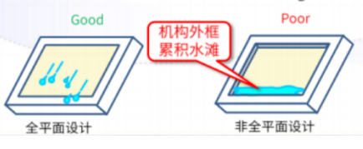

3.11.2 Do not use the frame of the touch screen and whole machine as a conductor. Use insulation tapes to separate touch screen frame from whole machine frame. This is because water through frame of touch screen and whole machine will form a conductor, and cause a signal similar to the touch of a human hand, which results in false touch behavior.

3.11.3 The cover surface need to do waterproof treatment,which can reduce the strength of water staying on the cover surface, as shown in the following figure

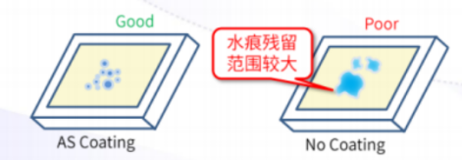

3.12 About the non-print black edge which is inlaid structure ,causing the edge is untouchable,the general reason is that the thickness of the front frame of the machine is too large, resulting in fingers unable to touch the edge and corner area. We advise that the visual area of the case front frame should be opened larger, and the unilateral side is at least 3mm larger than the touch display area, and the thickness of case front frame should be reduced, we advise that the thickness of the case front frame is not greater than 2mm.

3.13. If the touch screen has a "fog" phenomenon during the assembly process (as shown below), the main reason is , machinine in the high humidity environment, which causing the water vapor between the touch screen and the liquid crystal cannot be dispersed for a while and the water vapo is attached to the inner surface of the touch screen. We have the following suggestions for this:

3.13.1 If it has line fog on the corner parts , the machine should be aging bake,the screen "fog" will evaporate and disappear after the temperature rises .

3.13.2 The joint sealing of the double-sided tape between the touch screen and the LCD screen should be ensured to reduce the entry of water vapor

3.13.3 If there is a large area of fog between TP and module, it is necessary to remove the machine and wipe it with a clean dust-free cloth before assembling the whole machine

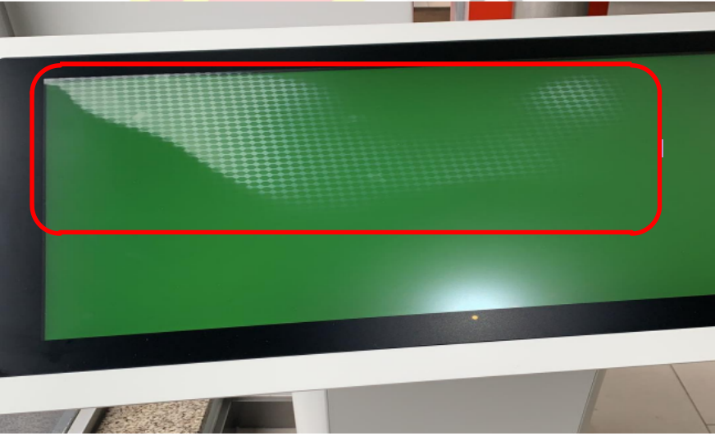

**4. connecting schematic diagram of the touch screen cable and control card**

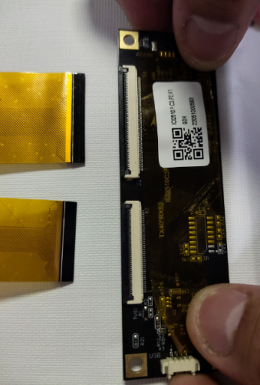 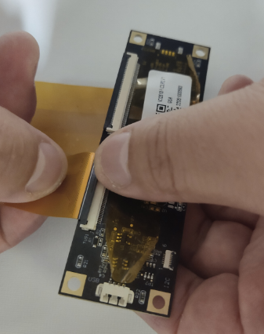

1 2

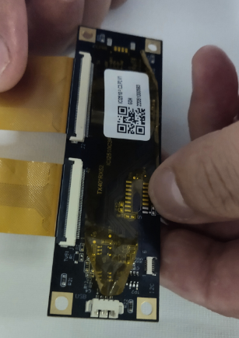 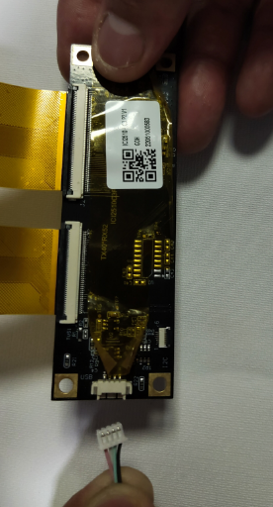

3 4

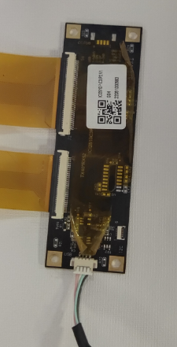

5

**5. Touch screen USB data cable PIN definition diagram**

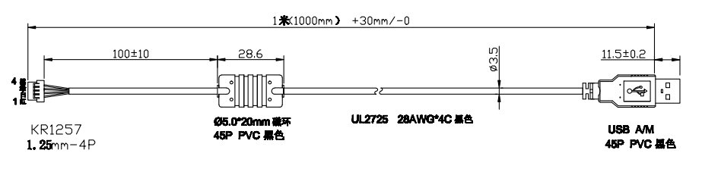

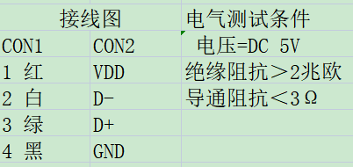

When changing the data cable, please pay attention to follow our data cable PIN definition strictly , if not,wiring errors will burn the control card directly

**6.Upgrade procedure guide of touch screen**

**6.1** **ILITEK 2511/2510/2312/2315 Control card burning steps**

6.1.1 Connect the control card to the computer via USB cable and open the software



6.1.2 Click "Search" to read the information inside the control card

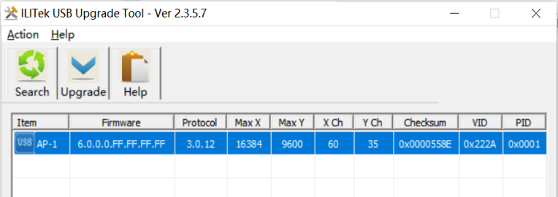

6.1.3 Click load Hex , load the FW that needs to be burned on the desktop, then click OK

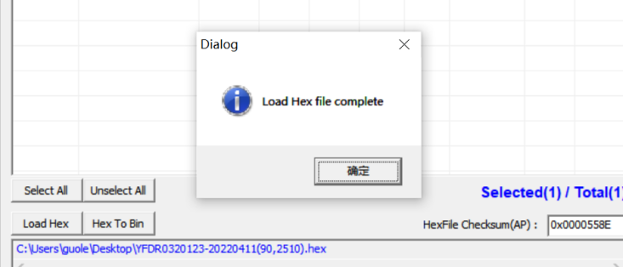

6.1.4 Click UPgrade to bring up the dialog, and then click OK to burn the program

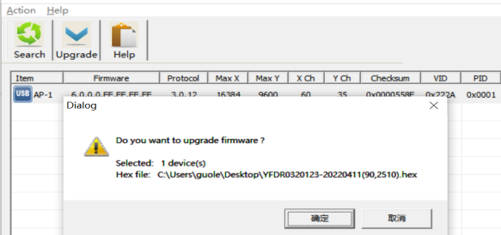

6.1.5 After the program is successfully burned, the following dialog box will pop up, and then click OK, close and exit

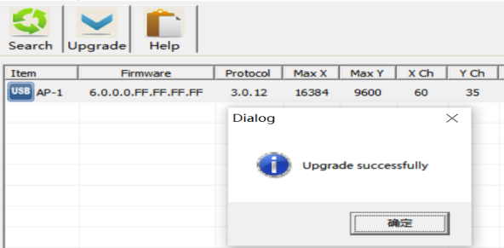

**6.2 ILITEK 2322/2323/2316 Control card burning steps**

6.2.1 Connect the control card to the computer via USB cable，open the software:



6.2.2 Go to the burning software interface ， click windows studios ITS

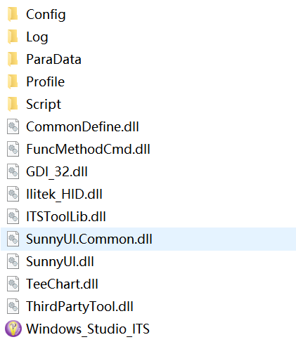

6.2.3 Go to the interface, click Disconnect and make it green at the bottom

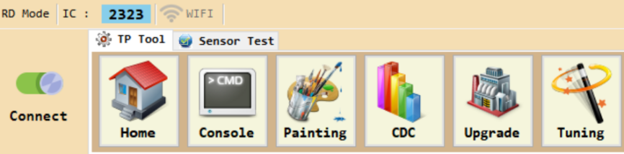

6.2.4 Click upgrade,enter the following interface

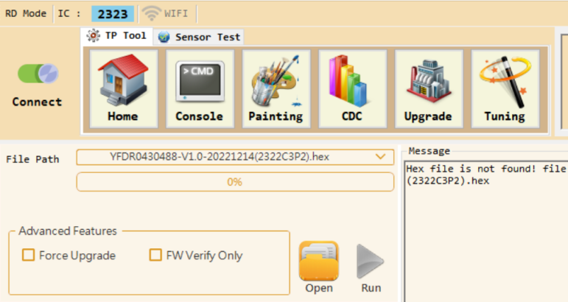

6.2.5 Click open,load FW:

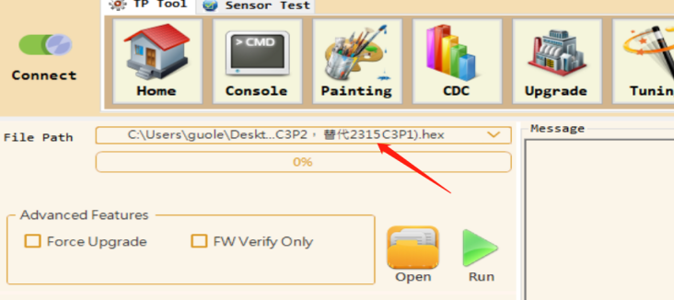

6.2.6 Click run , burn the FW automatically, and then shut it down

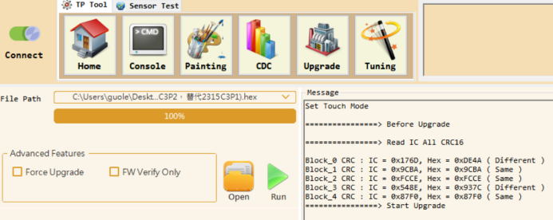

**6.3 EETI 82H series /80H series /31 series and other control card burning steps**

6.3.1 Click Burn Configuration ,enter the burn interface and double-click update2 pointed by the arrow

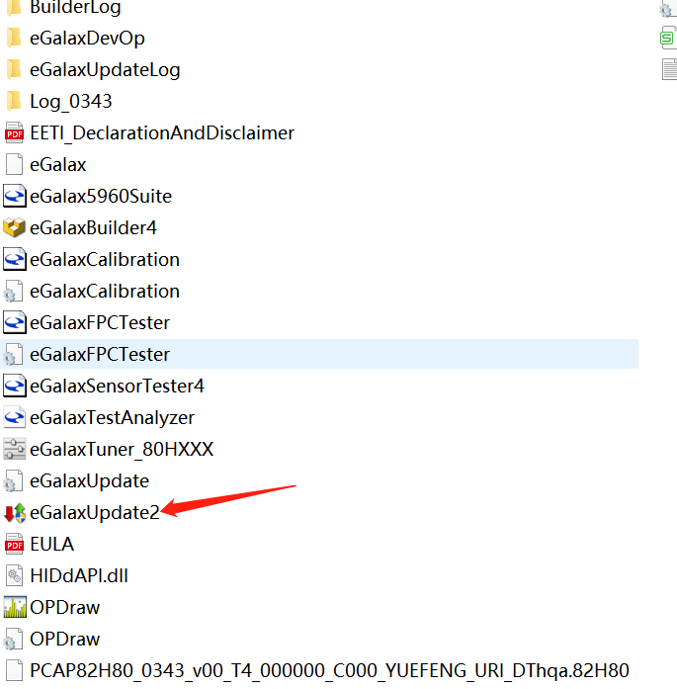

6.3.2 enter the following interface,click Load Image, load fw 82H80_0343_00T4

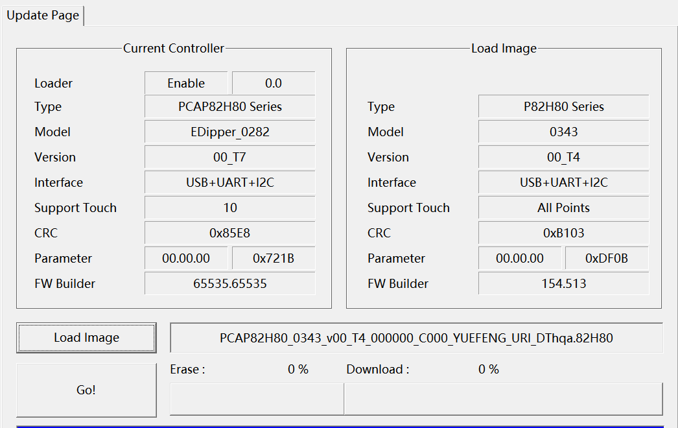

6.3.3 Click GO, enter the burning program stage;

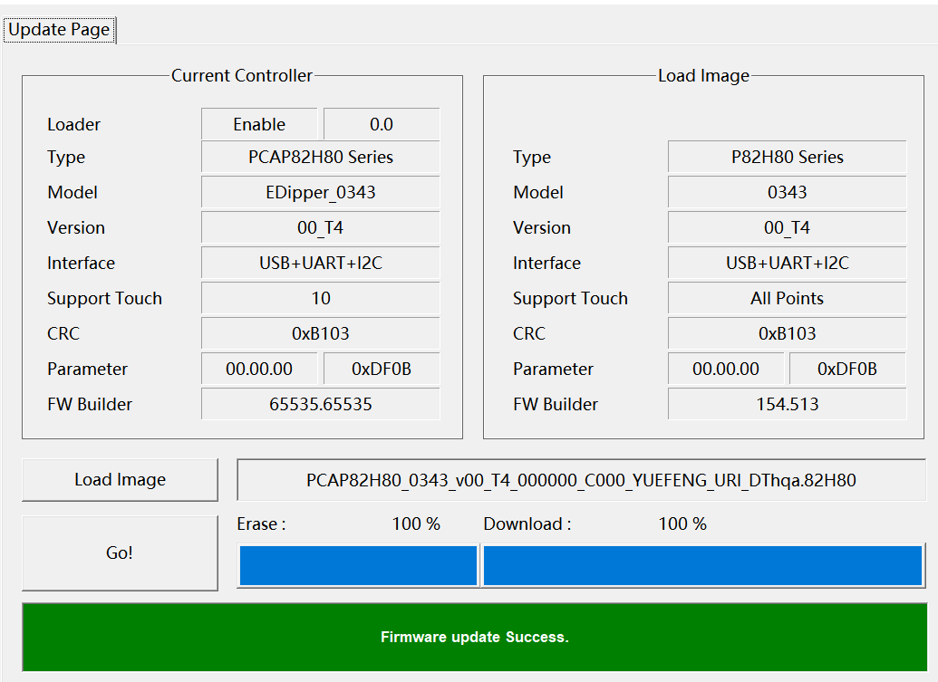

**7, Touchscreen test guide**

7.1 ILI2511/2510/2312/2315 series test steps:

7.1.1 Install the sensor test software and open the sensor test software

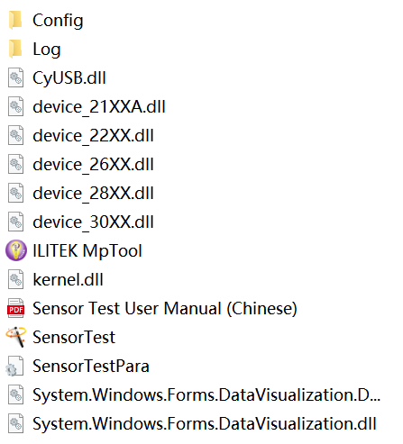

7.1.2 Click on sensor Test, then type "ilitek" in the user name field, and click" configuration files"to load the test configuration file

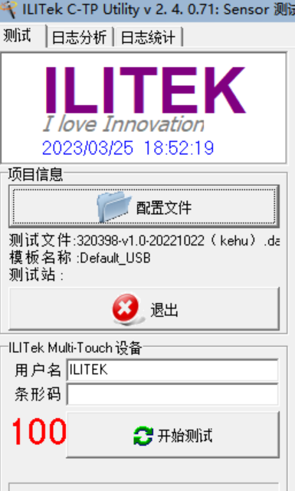

7.1.3 Click to read the panel configuration, pop up "OK" button and click, then click "Save and exit" in the lower right corner, then pop up the OK button, click OK, and enter the test interface.

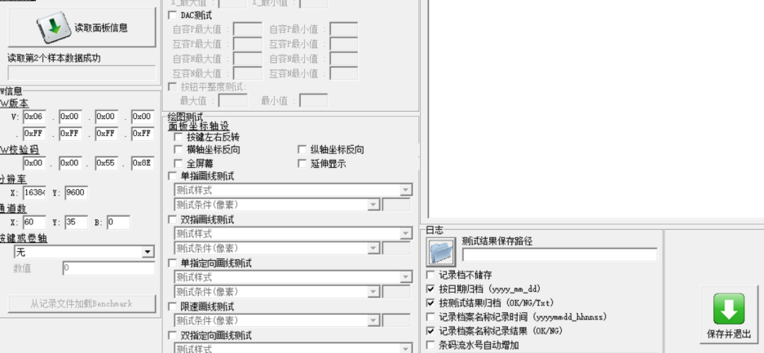

7.1.4 Click Start test, enter the test interface. After the test is completed, the test PASS indicates that the touch screen is OK, and the test Fail needs to be analyzed

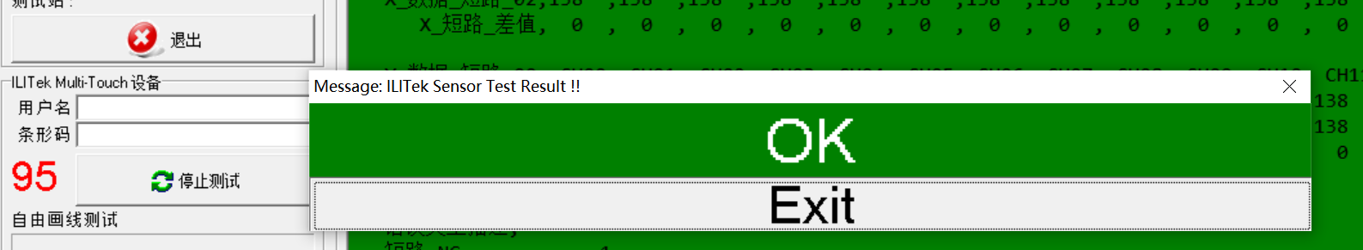

7.2 Ili 2322/2323/2316 series test steps

7.2.1 Open the test software, as shown below

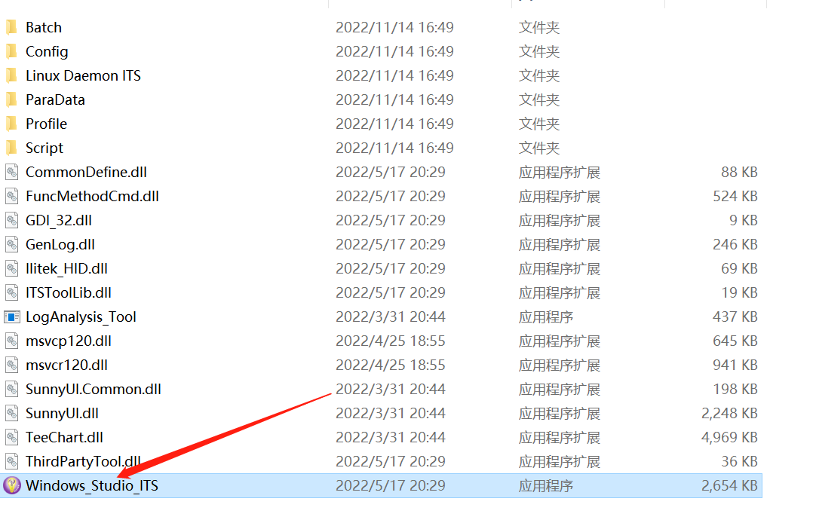

7.2.2 Double-click and enter the test interface, click connect to enter the sensor test interface, as shown below;

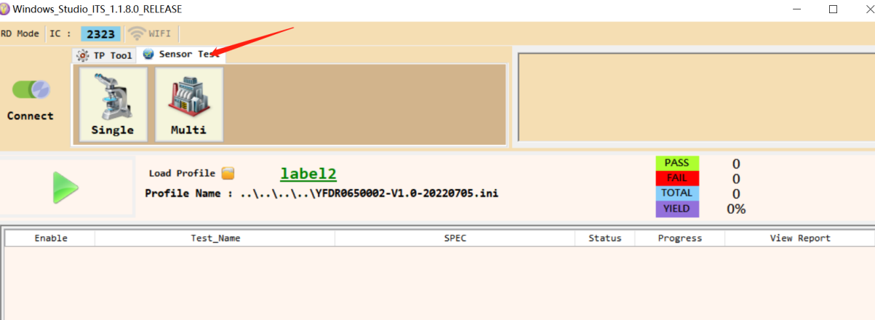

7.2.3 Click Load profile to load the test configuration file, as shown below;

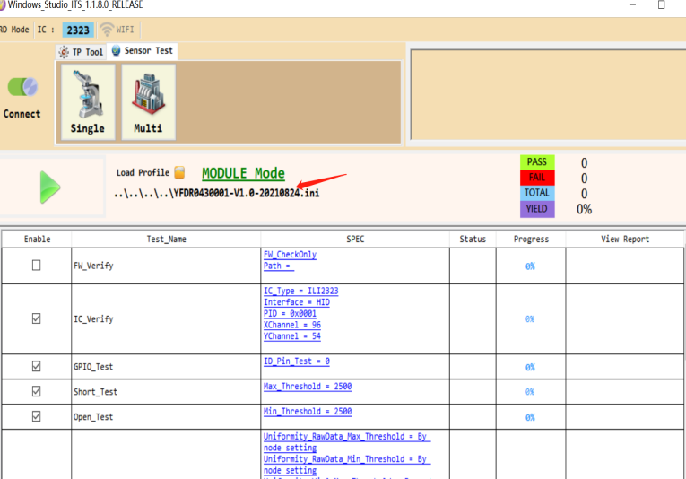

7.2.4 Click the green arrow on the left to start the test, as shown below:

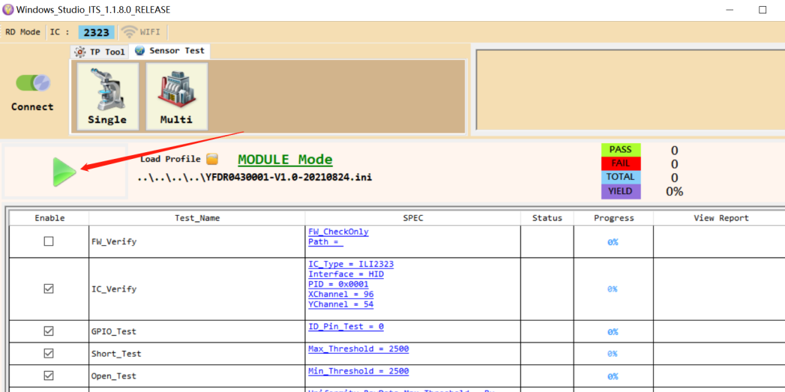

After the test is completed, the test PASS indicates that the touch screen is OK, and the test fail needs to be analyzed

**7.3 EETI 82H series /80H series /31 series and other control card test procedures**

7.3.1 Click EETI test configuration , enter the test interface and double-click sensor test 4 pointed by the arrow.

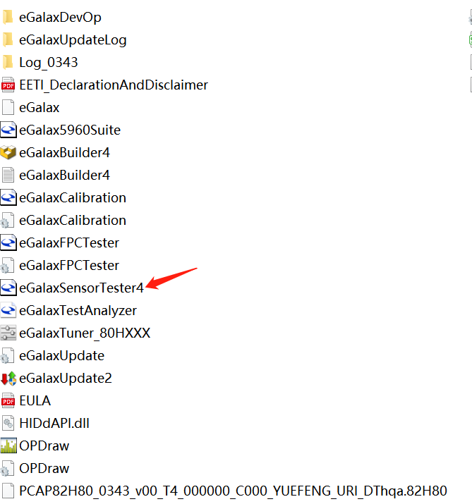

7.3.2 Click sensor test 4, enter the test interface

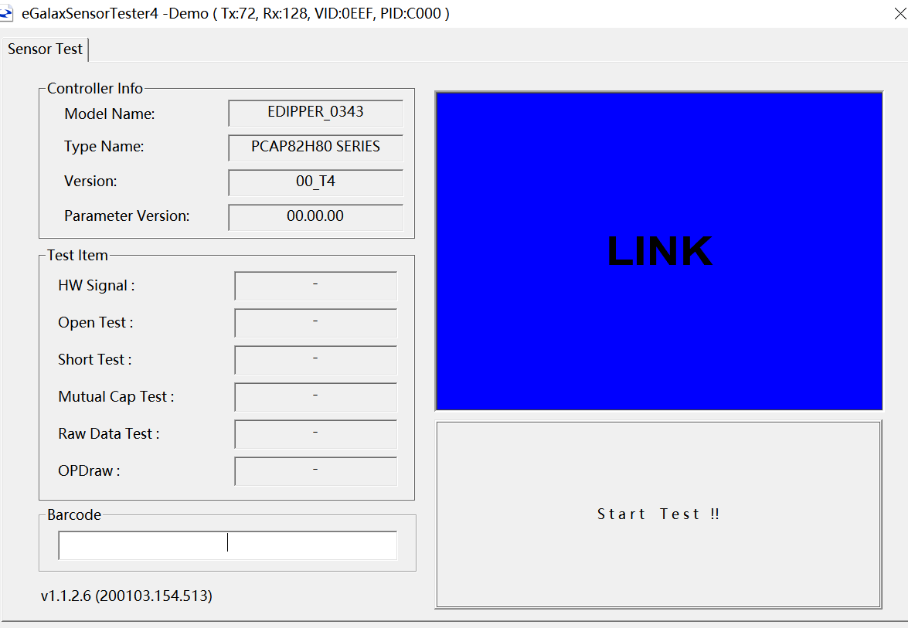

7.3.3 Click sensor test to start the test

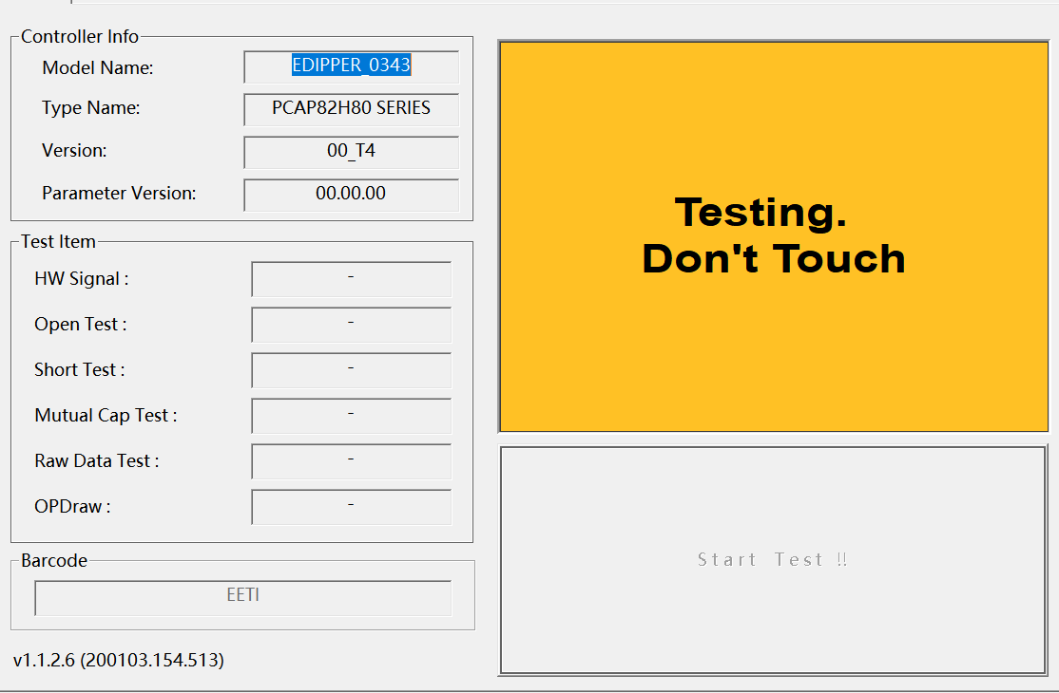

After the test is completed, the test PASS indicates that the touch screen is OK, and the test Fail needs to be analyzed

**8, Direction change guide of touchscreen**

**8.1 ILI 2510/2511/2312/2315 series**

8.1.1 Open the debugging tool, as shown below:

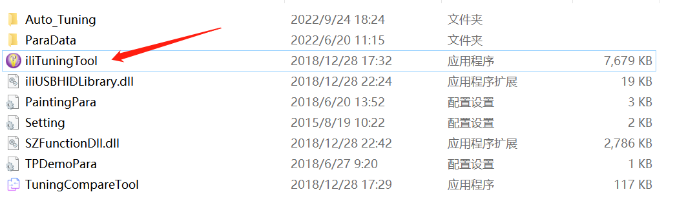

8.1.2 Double-click to go to the debugging tool page, click Disconnect and click OK, as shown below:

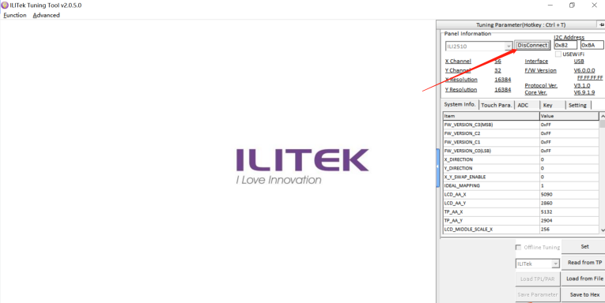

8.1.3 Find out "system info" in the information bar, as shown below

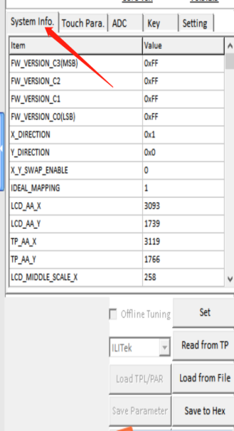

8.1.4 Find X-direction (X-axis DIRECTION), y-direction (Y-axis DIRECTION) and X-Y-swap-enable (X/Y SWAP direction) respectively in the column"system info", input the corresponding 0 or 1, and then click set below to write it, as shown below:

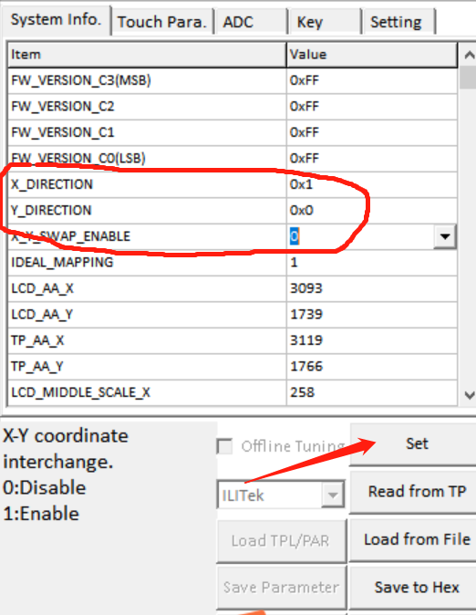

8.1.5 After the direction debugging is OK, then close and exit the debugging tool

**8.2 ILI 2322/2323/2316 series**

8.2.1 Open the debugging tool, as shown in the following figure

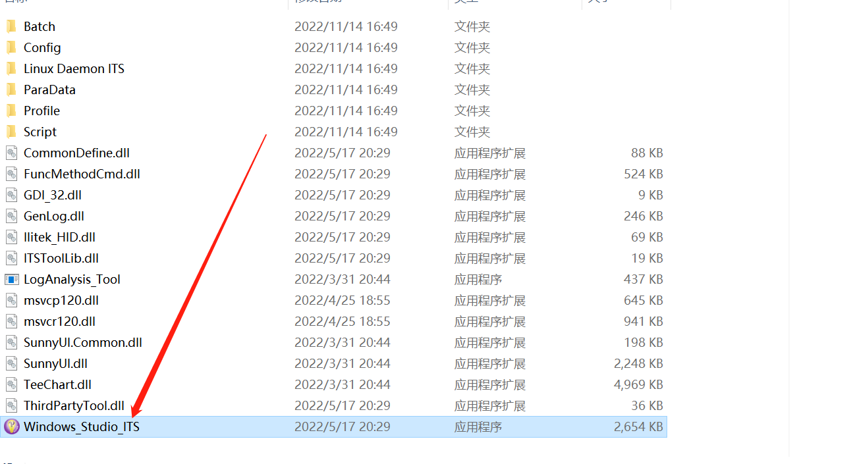

8.2.2 Double-click to enter the debugging interface, click connect, then click Tuning, click OK, as shown below:

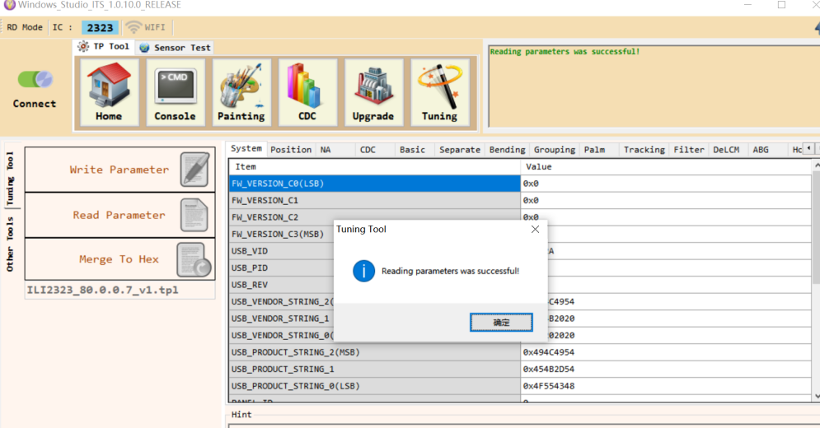

8.2.3 In the column" position", find x-direction (X-axis DIRECTION), Y-direction (Y-axis DIRECTION), X-Y-swap-enable (X/Y SWAP direction), input the corresponding 0 or 1, and then click "write parameter" on the left and input

